1. **Write a blog on the difference between document and window object**

**Introduction**

As developers, we often interact with two essential objects within the **DOM** (Document Object Model): the Document object and the Window object. While they may seem similar at first glance, they serve distinct purposes and have different properties and methods. In this blog, we'll delve into the dissimilarities between these fundamental objects to gain a deeper understanding of how they function.

**Document Object**

The Document object represents the HTML document loaded in the browser window. It serves as an entry point to the web page's content and provides methods and properties to manipulate it. Essentially, the Document object represents the structure and content of the page.

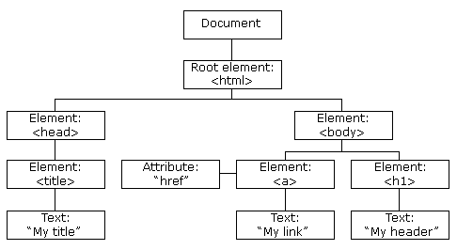

**Window Object**

On the other hand, the Window object represents the browser window that contains the Document object. It serves as a global object for the web page and provides methods and properties related to the browser window itself, such as controlling navigation, opening new windows, and managing timing events.

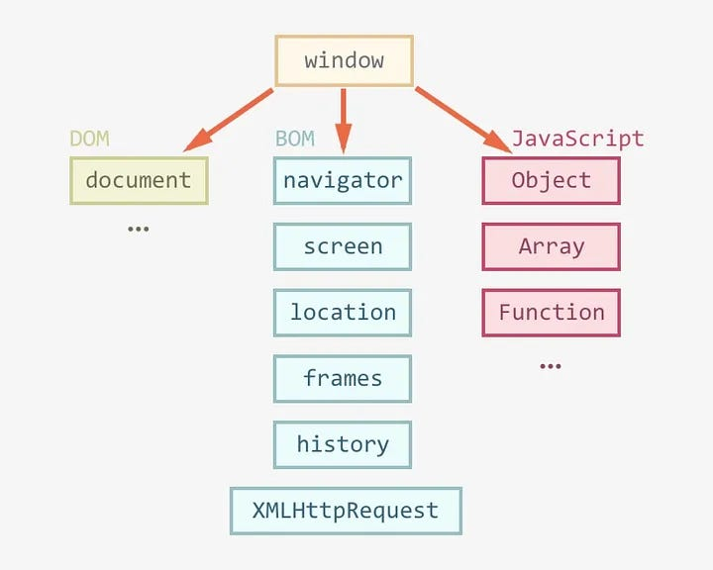

**Differences in Purpose and Scope**

**Scope**:

The Document object's scope is limited to the content of the web page, including HTML elements, text, images, and other media. It represents the structure and content of a single document. In contrast, the Window object's scope extends beyond the document to encompass the entire browser window, including tabs, frames, and iframes.

**Manipulation**:

While both objects provide methods for manipulation, they operate on different aspects of the web page. The Document object allows developers to manipulate the content, structure, and styling of the HTML document, such as adding or removing elements, changing text content, or modifying CSS styles. On the other hand, the Window object facilitates actions related to the browser window itself, such as resizing the window, opening new tabs or windows, or controlling navigation.

**Hierarchy**:

The Document object exists within the context of the Window object. In other words, the Window object serves as the container for the Document object and provides access to it through properties like **window.document** or simply **document**.

**Conclusion**

The Document and Window objects are both essential components of the **DOM**, they serve distinct purposes and operate within different scopes. The Document object represents the content and structure of the **HTML** document loaded in the browser window, allowing developers to manipulate its elements and properties. In contrast, the Window object represents the browser window itself, providing methods and properties for controlling its behaviour and interaction with the user. Understanding the differences between these objects is crucial for effective web development and **DOM** manipulation.

Top of Form